Experiment No – 11
Title / Aim :- Use JavaScript timers (setTimeout(), setInterval()) and ES6 modules (import/export) to build a dynamic countdown or class scheduler with real-time updates and responsive layout.
Software/Tools Required :-
- Visual Studio Code (VS Code)
- Google Chrome / Any Web Browser
- HTML
- JavaScript
Theory : -
JavaScript timers and ES6 modules are used to develop dynamic and interactive web applications. The setInterval() method updates the countdown every second, while setTimeout() displays temporary notifications before a class starts. ES6 modules use import and export to organize code into separate files. The CampusSync Smart Class Scheduler displays class details, including subject name, faculty, classroom, start time, and end time. It automatically highlights the current class, updates the countdown in real time, and switches to the next class when the current class ends. CSS provides a responsive dark-themed interface.

Output
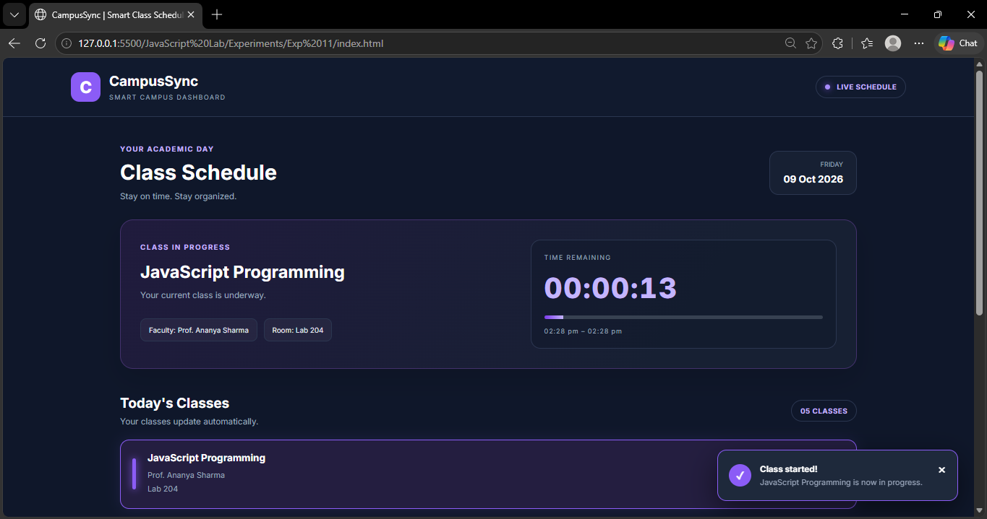
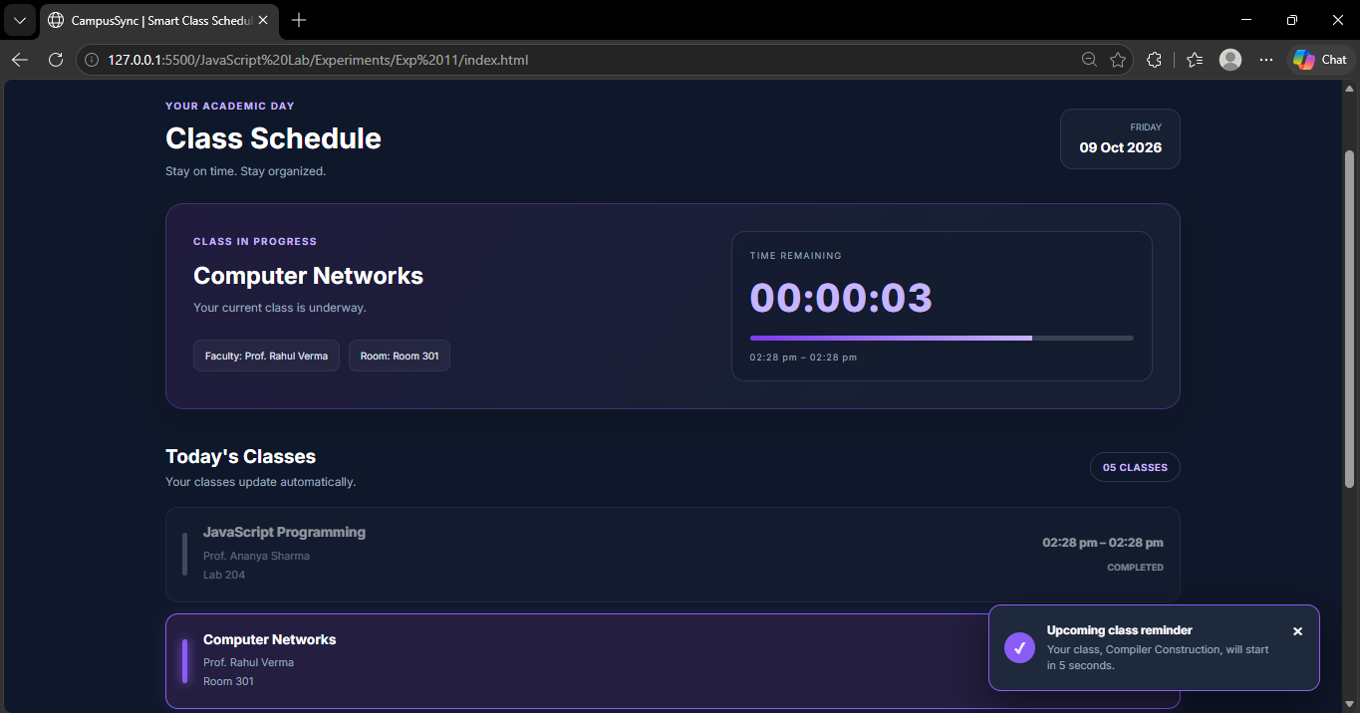
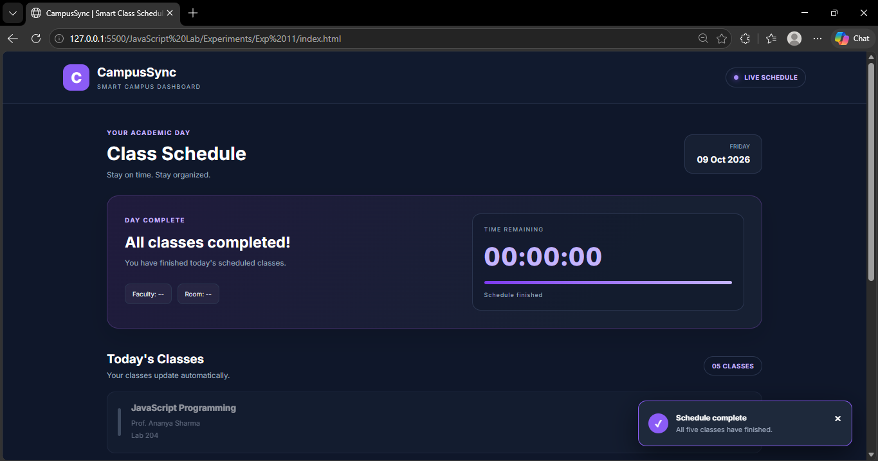

Result / Conclusion :-
The CampusSync Smart Class Scheduler was successfully developed using HTML, CSS, and JavaScript. It demonstrates real-time countdowns, automatic class transitions, and temporary notifications using setInterval() and setTimeout(). ES6 modules were used to organize the code, and the responsive interface displays class details dynamically.

